COVID-19 Restrictions AT Carlton le Willows

We are pleased to announce that as of the 25 of July 2020, Nottingham Sycamore Table Tennis Academy is now reopening under both Government and Table Tennis England guidelines.

The current guidelines in place from Table Tennis England can be viewed here:

https://tabletennisengland.co.uk/clubs/clubs-guidance/ready-to-return/

Whilst all practice sessions will now be running as per the standard timetable, the following COVID-19 restrictions will apply

*** PLEASE NOTE THESE RESTRICTIONS MAY CHANGE AS NEW GUIDANCE IS REALISED FROM GOVERNMENT AND TTE ***

- If you are showing coronavirus symptoms, or any of your household are self-isolating, you must stay at home and not use our facilities.
- You must contact Mick Pestka or Jason Ramage by telephone if you or any of your contacts/household test positive for Coronavirus
- If you wish to play, you must book your place at a session in advance, we will be using Whats App to book your sessions.
- You must sign in on arrival so that we can keep a track of who has visited
- You must adhere to social distancing guidelines at all times
- Members must adhere to good hygiene practices throughout their time at the Club
- Equipment cannot be shared within a session. Players should bring their own bats, and any equipment belonging to the Club must be cleaned after use.
- Each player will be required to have their own ball, so that players need only to handle their own ball. Players should kick/hit the other players ball back with a racket.
- Players will be allowed to train within bubbles of 2-6 players.
- Table tennis etiquette which requires contact (shaking / slapping hands etc) must be suspended for the time being.
- Players should use one side of the table and not swap ends.
- There must be the minimum of a ten-minute break when players using the same table are swapping over.
- Players must wipe down their side of the table upon finishing their session.
- Proper hand washing with soap (or hand sanitiser as a second best) should occur before and after any activity at the club.
- Members must bring their own drinks bottles which are brought in and taken away every session.
We appreciate the above measures are not ideal, but they are in place for the safety of everyone at the club. If anyone fails to observe these measures or appears to be ignoring them, they will be asked to leave with immediate effect.

As soon as we are allowed to ease these restrictions, we will let you all know.

We are committed to the safety and welfare of its members. As such, we will take the following measures:
- We will keep members updated with changes in processes or protocol relating to Club activity
- We will keep communal areas closed where possible until restrictions are further lifted, so no access to Kitchen, Social Area or changing rooms
- We will implement a booking system to limit the numbers attending sessions to enable social distancing, using Whats App
- We will provide information on good hygiene practises
- We will ensure our Coaches are equipped with the necessary knowledge to deliver sessions in accordance with Government and Table Tennis England Guidelines
- We will make decisions based on the best interest of our membership
- We will regularly review and update our risk assessment relating to COVID-19.

Our proposed layout for practise will be as follow:

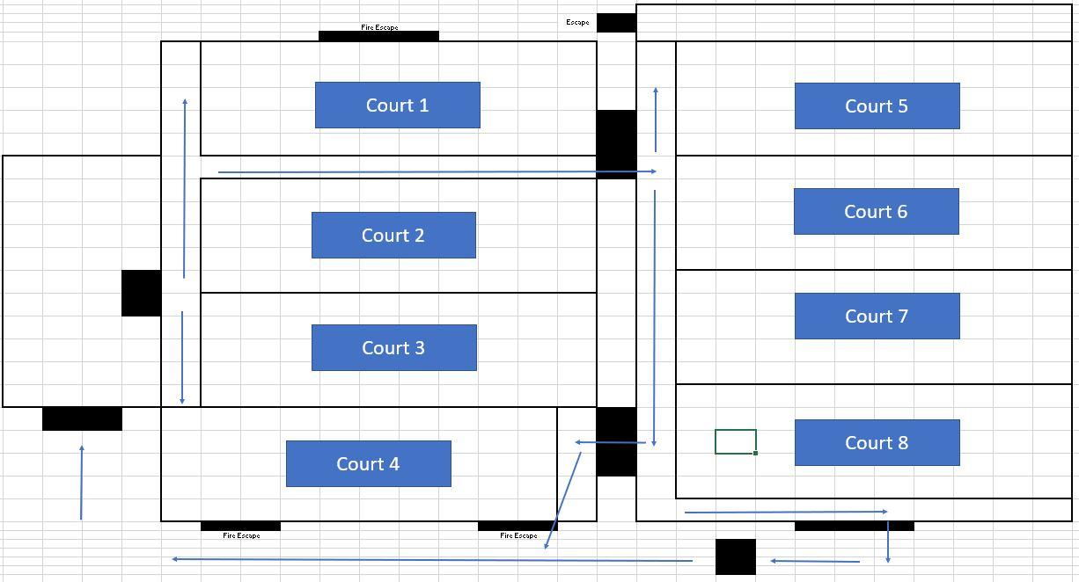

The disabled toilet door will be kept open for people to use to wash their hands only.

Cost per 55 min session will be £2, if there is space and you are able to book onto the 2nd session on the same day, there will be an additional £1 charge.

CORRECT MONEY MUST BE BROUGHT AND PAID PRIOR TO YOUR SESSION

Kind Regards
Nottingham Sycamore Table Tennis Academy Committee

